30th April 2019

**ADAC TCR Germany season start in Oschersleben**

Mike Halder and Antti Buri were the winning drivers in the ADAC TCR Germany season opener at Oschersleben last weekend. The Championship which has Japanese premium tyre manufacturer YOKOHAMA as exclusive tyre supplier, will also visit Most in the Czech Republic, Red Bull Ring in Austria, Zandvoort in The Netherlands, and the Nürburgring, Hockenheimring and Sachsenring in Germany throughout the season.

In Race 1, Halder followed pole-man Max Hesse and then overtook him at the restart after a safety car period. Reigning champion Harald Proczyk finished third in his maiden race with the Hyundai i30 N.

After finishing fourth in Race 1, Buri took showed his class in Race 2 making a perfect start and passing the two cars on the front to take the lead. After a safety car intervention, Théo Coicaud took second, but he was under the threat of Halder who was followed by Hesse and Proczyk. In lap 10, Halder managed to overtake Coicaud for second and started chasing Buri. Proczyk and Coicaud had a close fight for the third position, they clashed and Proczyk moved up to third. However, after the race he was given a ten-second penalty for the incident and dropped from third to sixth.

The TCR Germany will resume at the “Autodrom Most” in the Czech Republic on 17th-19th May.

Race 1

1. M. Halder (Profi-car Team, Honda Civic FK7)

2. M. Hesse (Team Engstler, Hyundai i30 N)

3. H. Proczyk (HP Racing Int., Hyundai i30 N)

Race 2

1. A. Buri (LMS Racing, Audi RS 3 LMS)

2. M. Halder (Profi-car Team, Honda Civic FK7)

3. M. Hesse (Team Engstler, Hyundai i30 N)

Overall standings

1. Halder 79 pts

2. Hesse 72

3. Buri 68

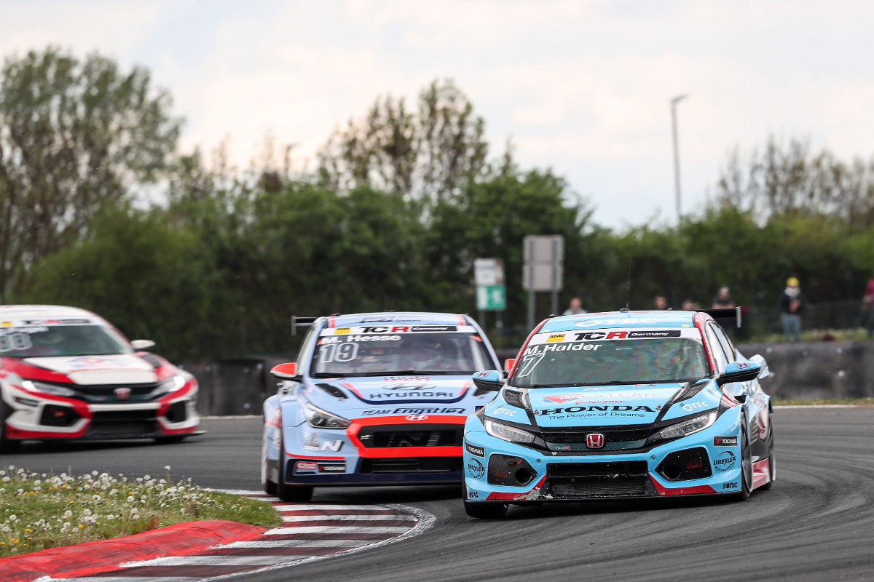

*2019 GER Oschersleben R1, Mike Halder pic ADAC TCR Germany Gruppe C*